Namespace:

Virtual directory for different php files. If 2 files have same class names, in order to distinguish them.

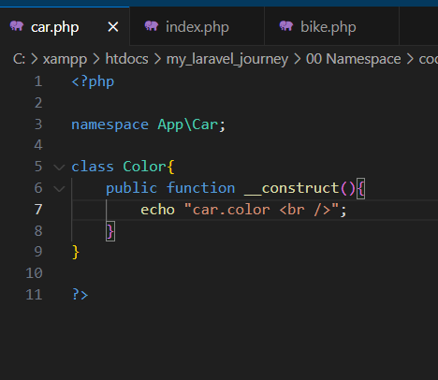 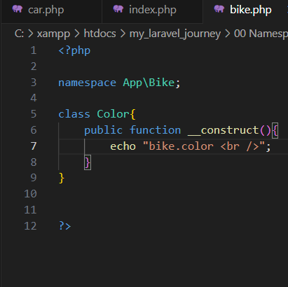

car.php and bike.php have same class name. In index.php, both files are included. But still there is a problem. Which class is used to create object.

To solve this, use NAMESPACE

